**LAB 1:**

**Assignment 1: Identifiers , Variables, Datatypes :**

1.a). Write a python program for the given problem description:

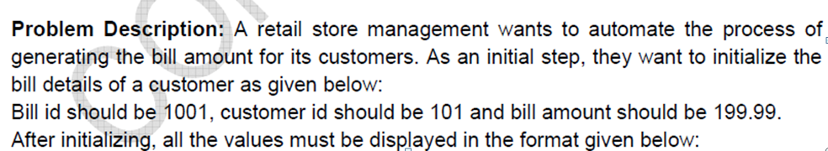

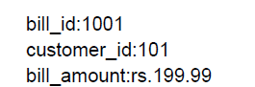

**Assignment 2: Input , output operations and operators :**

2.a Write statements for the following:

Read an integer and add 100 to it.

Read a float and add 22.45 to it.

Read a string and concatenate with another string

2.b

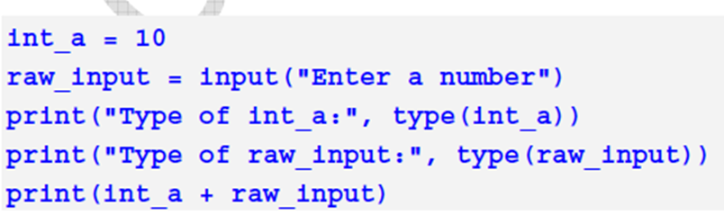

2. c

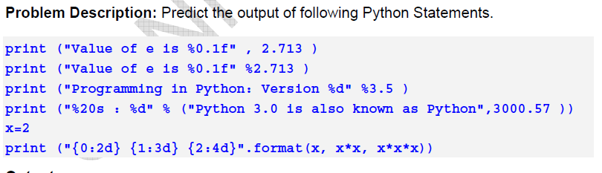

2. d

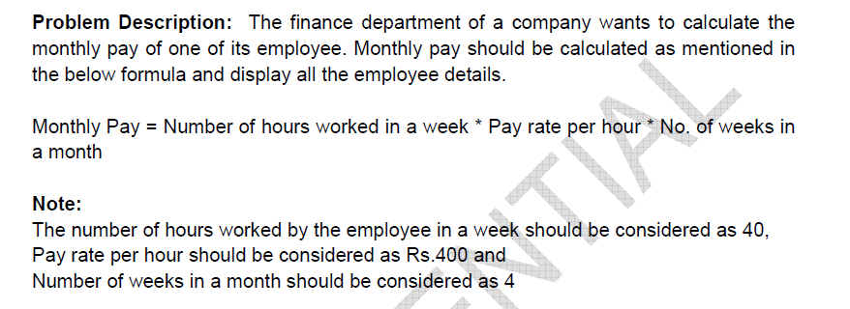

2.e

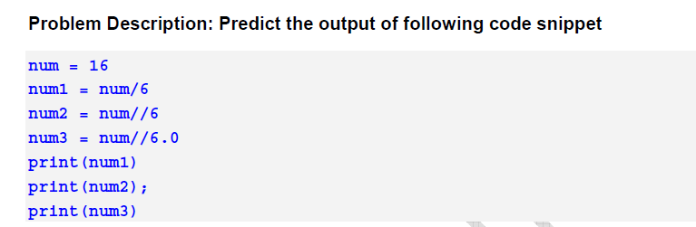

2.f

Predict the output:

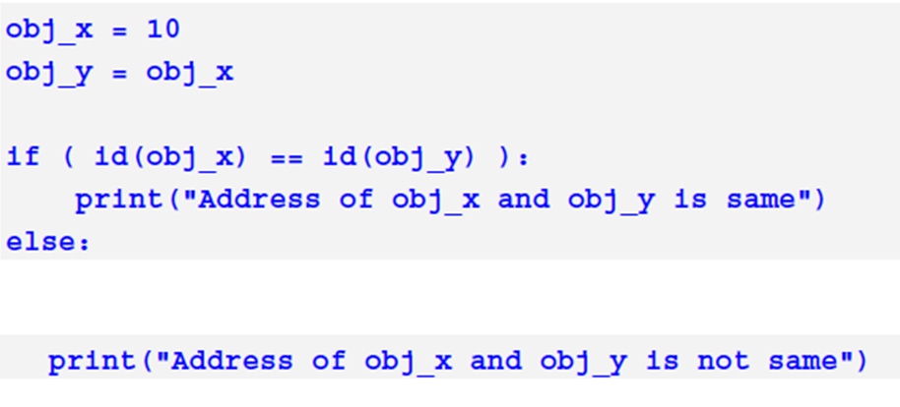

2.g

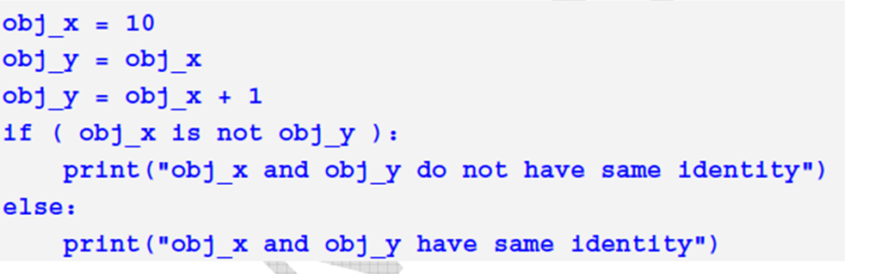

**Assignment 3: Selective Control Structures:**

3.1

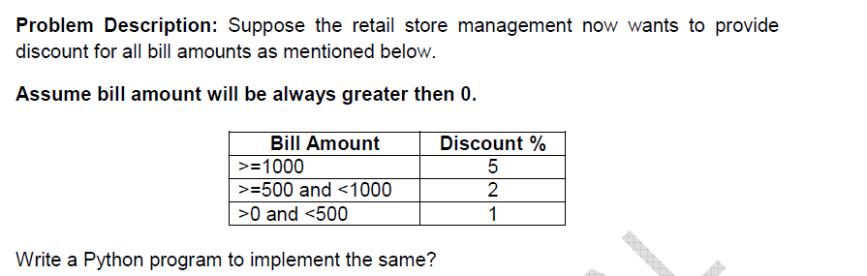

**Assignment 4: Iterative Control Structures:**

Predict the output and verify :

4.1.

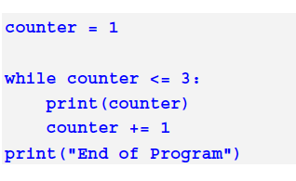

4.2.

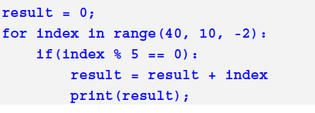

4.3

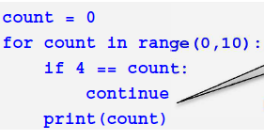

4.4. Write a python program to print the following format for a n value(in this output n is 7)

1   
2   4   
3   6   9   
4   8   12   16   
5   10   15   20   25   
6   12   18   24   30   36   
7   14   21   28   35   42   49

1

2 2

3 3 3

4 4 4 4 for n=4 try different patterns